Name ________________________ Date___________

Algebra II

Polynomials Test Practice

**Multiple Choice**

1) Divide. (Careful! This is tricky.) 

2) Given , use synthetic division to evaluate  . ___________

**3) What are the roots of the function****?**

4) Where does the graph of  cross the x-axis?

5) **The zeros of a polynomial function are** **and 2. Which could be the function?**

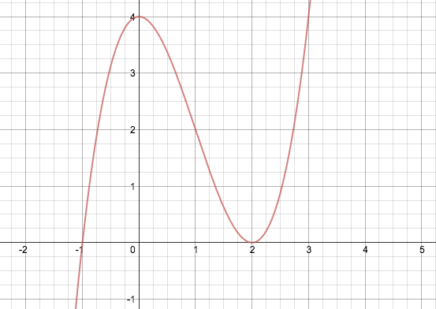**6) Which zero has a multiplicity of two?**

Divide:

7)  7) ____________________

8)  8) ____________________

**For 9 - 10, give the zeros and their multiplicity. (You do not have to give the function.)**

9)  9) ____________________

10)  10) ____________________

11) Complete a function chart, and ***write the equation*** of a polynomial that has

zeros at –2 (multiplicity of 2) and 3.

12) Complete a function chart, and write the equation of a polynomial that has

zeros at 0, 4, and –.

**Solve the following polynomials. Give all zeros.**

13) 

14) 

15) 

16) 